React is a JavaScript library for building user interfaces.
React is used to build single-page applications.
React allows us to create reusable UI components.
What is React?
React, sometimes referred to as a frontend JavaScript framework, is a JavaScript library created by Facebook.
React is a tool for building UI components.

How does React Work?
React creates a VIRTUAL DOM in memory.
Instead of manipulating the browser's DOM directly, React creates a
virtual DOM in memory, where it does all the necessary manipulating,
before making the changes in the browser DOM.
React only changes what needs to be changed!
React finds out what changes have been made, and changes only
what needs to be changed.

Setting up a React Environment:
Getting Started with React: Installation and Environment Setup
- Node.js and npm: Download and install Node.js (https://nodejs.org/en/download/package-manager/current) as it provides the runtime environment for JavaScript code execution. npm (Node Package Manager) is bundled with Node.js and is used to manage project dependencies.
- Create React App (CRA): Using Create React App (CRA) to establish a new React project with minimal configuration. Run npx create-react-app my-react-app in your terminal, replacing my-react-app with your desired project name.

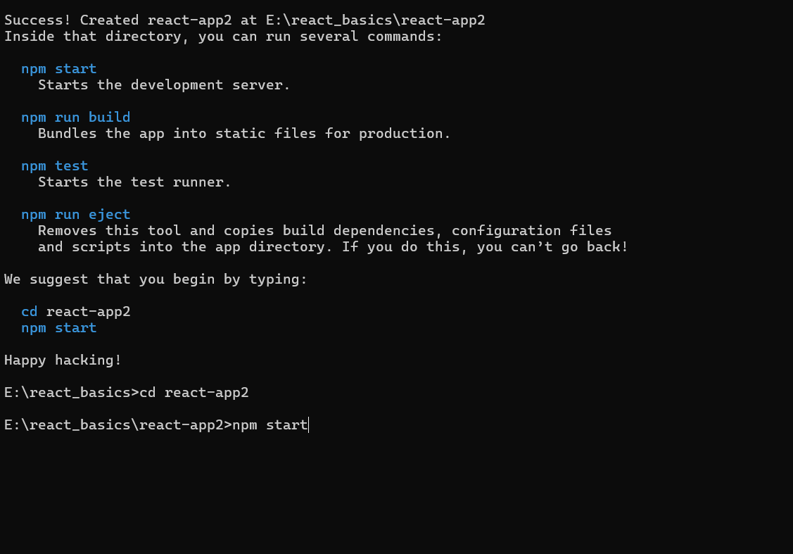

If you have npx and Node.js installed, you can create a React application by using create-react-app.
If you've previously installed create-react-app globally, it is recommended
that you uninstall the package to ensure npx always uses the latest
version of create-react-app.
To uninstall, run this command: npm uninstall -g create-react-app.
Run this command to create a React application named my-react-app:
npx create-react-app my-react-app
The create-react-app will set up everything you need to run a React application.

How to Run the React Application
Now you are ready to run your first real React application!
Run this command to move to the my-react-app directory:
cd my-react-app
Run this command to run the React application my-react-app:
npm start
A new browser window will pop up with your newly created React App! If not, open your browser and type localhost:3000 in the address bar.
The result:
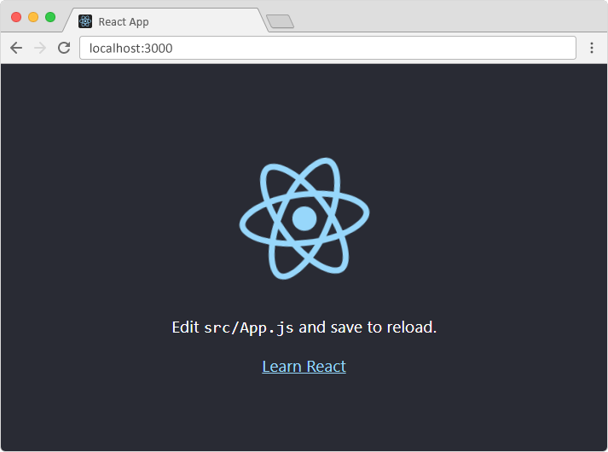

Modify the React Application
So far so good, but how do I change the content?
Look in the my-react-app directory, and you will find a src folder. Inside the src folder there is a file called App.js, open it and it will look like this:
/myReactApp/src/App.js:
import logo from './logo.svg';
import './App.css';

function App() {
return (
<div className="App">
<header className="App-header">
<img src={logo} className="App-logo" alt="logo" />
<p>
Edit <code>src/App.js</code> and save to reload.
</p>
<a
className="App-link"
href="https://reactjs.org"
target="_blank"
rel="noopener noreferrer"
>
Learn React
</a>
</header>
</div>
);
}
export default App;
Try changing the HTML content and save the file.
Notice that the changes are visible immediately after you save the file, you do not have to reload the browser!
Example
Replace all the content inside the <div className="App"> with a
<h1> element.
See the changes in the browser when you click Save.
function App() {
return (
<div className="App">
<h1>Hello World!</h1>
</div>
);
}
export default App;

Notice that we have removed the imports we do not need (logo.svg and App.css).
The result:
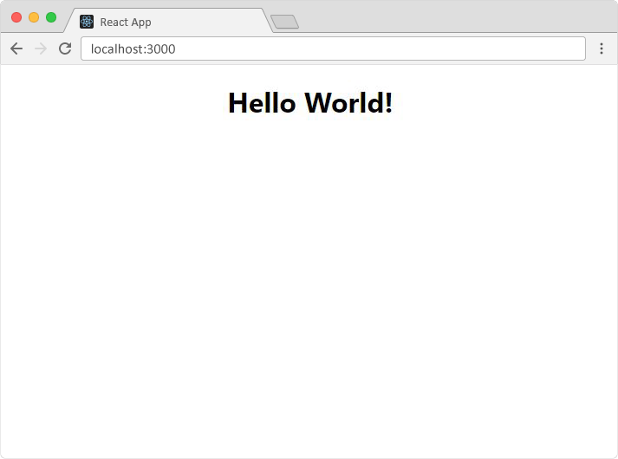

What's Next?
Now you have a React Environment on your computer, and you are ready to learn more about React.
In the rest of this tutorial we will use our "Show React" tool to explain the various aspects of React, and how they are displayed in the browser.
If you want to follow the same steps on your computer, start
by stripping down the src folder to only contain one file: index.js. You should also remove any
unnecessary lines of code inside the index.js file to make
them look like the example in the "Show React" tool below:
Example
Click the "Run Example" button to see the result.
index.js:
React's goal is in many ways to render HTML in a web page.
React renders HTML to the web page by using a function called createRoot() and its method render().
The createRoot Function
The createRoot() function takes one argument, an HTML element.
The purpose of the function is to define the HTML element where a React component should be displayed.
The render Method
The render() method is then called to define the React component that should be rendered.
But render where?
There is another folder in the root directory of your React project, named "public".
In this folder, there is an index.html file.
You'll notice a single <div> in the body of this file. This is where our
React application will be rendered.

Virtual DOM (Document Object Model):
- React uses a virtual DOM, which is an exact copy of the real DOM.
- When there are modifications in the web application, React updates the virtual DOM first and then computes the differences between the real DOM and the virtual DOM.
- This approach minimizes unnecessary re-rendering and improves performance.
